

**Research & Vehicle Technology**

**“Infotainment Systems Product Development”**

**Drive Video Record**

**Feature Level Specification**

Version 1.1

**UNCONTROLLED COPY IF PRINTED**

**Version Date: June. 29, 2022**

**FORD CONFIDENTIALF**

**Revision History**

|  |  |  |  |
| --- | --- | --- | --- |
| **Date** | **Ver** | **Notes** | |
| **April. 17, 2022** | **1.0** | **Initial Release** | **Niu, Kobe (Y.) initial release for DVR feature.** |
| **June, 29, 2022** | **1.1** | **Update according to benchmark** | **Niu, Kobe (Y.) update.** |
|  |  |  |  |
|  |  |  |  |

**Table of Contents**

Revision History 2

1 Overview 5

1.1 System Diagram 5

1.2 Terminology and Abbreviations 5

2 Architectural Design 6

2.1 XXXXX-REQ-xxxxxx/A-DVR Onboard Client 6

2.2 XXXXX-REQ-xxxxxx/A-DVR Offboard Client 6

2.3 XXXXX-REQ-xxxxxx/A-DVR server 6

2.4 Physical Mapping of Classes 6

2.5 Logical Signal Mapping 6

2.6 DVRServer Interface 7

2.6.1 XXXXX-IIR-REQ-xxxxxx/A-DVRServer_Rx 7

2.6.2 XXXXX-IIR-REQ-xxxxxx/A- DVRServer_Tx 8

3 General Requirements 10

3.1 XXXXX-REQ-xxxxxx/A-Power Mode 10

3.1.1 Full Power Mode 10

3.1.2 Standby Mode 10

3.1.3 Sleep Mode 10

3.1.4 Power Mode Switch 10

3.2 XXXXX-REQ-xxxxxx/A-Preconditions of Recording 10

3.3 XXXXX-REQ- xxxxxx /A-AR Camera Integration 10

3.4 XXXXX-REQ- xxxxxx /A-Legal Regulation 11

3.5 XXXXX-REQ- xxxxxx /A-DVR System Communication 11

3.6 XXXXX-REQ- xxxxxx /A-Data Collection 11

4 Functional Definition 12

4.1 XXXXX-FUN-REQ-xxxxxx/A-Enable/Disable Video Record 12

4.1.1 Requirements 12

4.1.2 Use Cases 12

4.1.3 White Box View 14

4.2 XXXXX-FUN-REQ-xxxxxx/A-Video/Photo~~/Voice~~ Data Record and Save 17

4.2.1 Requirements 17

4.2.2 Use Cases 18

4.2.3 White Box View 20

4.3 XXXXX-FUN-REQ-xxxxxx/A-Video/Photo Display 26

4.3.1 Requirements 26

4.3.2 Use Cases 27

4.3.3 White Box View 28

4.4 XXXXX-FUN-REQ-xxxxxx/A-DVR Setting & Information Display 30

4.4.1 Requirements 30

4.4.2 Use Cases 32

4.4.3 White Box View 33

4.5 XXXXX-FUN-REQ-xxxxxx/A-Data Copy and Deletion 34

4.5.1 Requirements 34

4.5.2 Use Cases 35

4.5.3 White Box View 37

4.6 XXXXX-FUN-REQ-xxxxxx/A-Vehicle Monitoring 39

4.6.1 Requirements 39

4.6.2 Use Cases 40

4.6.3 White Box View 41

5 Appendix: Reference Documents 42

# Overview

The Drive Video Record (DVR) feature allows the user to capture the video/image from a camera while driving, and could save the record data on an external TF card or download to a smart phone via Wi-Fi.

The DVR system could capture the video of exterior environment automatically, and when collision happens, will capture/save a special video labeled as “emergency”, user could also trigger the video/image record manually to save the beautiful view or important scene, at the same time, the necessary information like VIN, date, time will be saved. Users could also preview/playback the video/image and config the system via the center stack or Ford APP, DVR will also provide vehicle monitor ability after ignition off.

The camera and DVR ECU is mounted behind the vehicle windshield glass without the obstruction from interior components, the video data is transferred via LVDS to IVI.

## System Diagram

Below is the B diagram of DVR system:

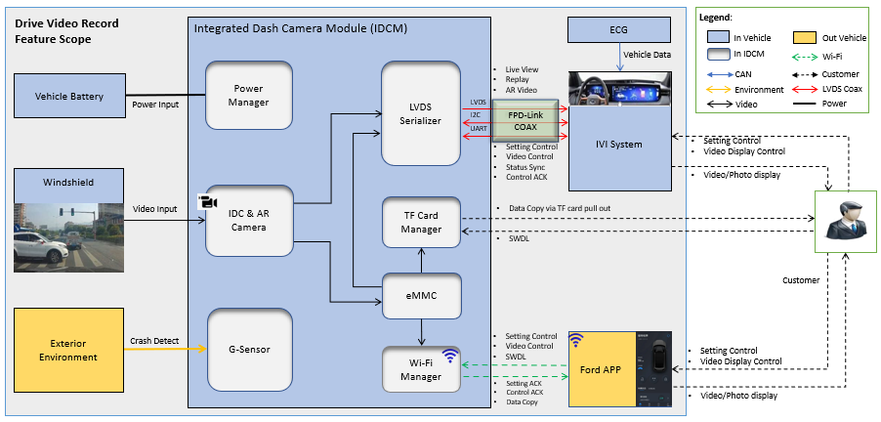

## Terminology and Abbreviations

The following table lists terminologies that are used in this document along with a brief description.

| **Term** | **Description** |
| --- | --- |
| APIM | Auxiliary Protocol Interface Module |
| DVR | Drive Video Record |
| ECG | Enhanced Central Gateway |
| FNV X.X | Fully Networked Vehicle Architecture X.X |
| GPS | Global Positioning System |
| HMI | Human Machine Interface |
| IDCM | Integrated Dash Camera |
| POC | Powered On Cable |

# Architectural Design

## XXXXX-REQ-xxxxxx/A-DVR Onboard Client

The DVR Onboard Client (DVROnboardClient) is located in vehicle, responsible for providing HMI to the user for liveview, sending record / playback or setting request to DVR server, get response and video/image from DVR server.

## XXXXX-REQ-xxxxxx/A-DVR Offboard Client

The DVR Offboard Client (DVROffboardClient) is located out of vehicle, responsible for providing HMI to the user for liveview, sending record / playback or setting request to DVR server, receive response and video/image from DVR server, DVROffboardClient is the Ford APP on user’s device like smart phone.

## XXXXX-REQ-xxxxxx/A-DVR server

The DVR Server (DVRServer) is responsible for processing video recording and playback requests, provide data collection and vehicle monitor function.

## Physical Mapping of Classes

The table below shows an example of how the logical classes that make up the DVR feature may be mapped into physical modules.

|  |  |
| --- | --- |
| **Logical Class** | **Physical Module (ECU)** |
| DVROnboardClient | IVI Centerstack, like SYNC/ SYNC+/ PDC/ Rigil |
| DVROffboardClient | Ford APP, like FordPass/ Lincoln Way/BEV APP |
| DVRServer | IDCM—Integrated Dash Camera Module |

## Logical Signal Mapping

The signals mentioned throughout this document shall refer to the signal’s logical name. The logical names shall be mapped to their actual signal names. Please use the table below to perform the mapping. Note: There may be cases where the actual signal name is used in this documentation.

|  |  |
| --- | --- |
| **Logical Name** | **Signal Name** |
| IGN_St | Ignition_Status |
| VehicleMode_St | KeyOffMde_D_Actl |
| DelayAccy_St | Delay_Accy |
| StartRecording_Rq |  |
| PublishRecordingStatus |  |
| StopRecording_Rq |  |
| ListRecordings_Rq |  |
| StartPlayback_Rq |  |
| PausePlayback_Rq |  |
| ResumePlayback_Rq |  |
| StopPlayback_Rq |  |
| MemoryConsumptionStatus_Rq |  |
| DVRSwtich_Rq |  |
| ManualVideoImage_Rq |  |
| DVRExtendWakeup_Rq | IVI_HMI_Showing? |
| VideoRecordSwitch_Rq |  |
|  |  |
|  |  |
| StartRecording_Rsp |  |
| StopRecording_Rsp |  |
| ListRecordings_Rsp |  |
| StartPlayback_Rsp |  |
| PausePlayback_Rsp |  |
| ResumePlayback_Rsp |  |
| StopPlayback_Rsp |  |
| MemoryConsumptionStatus_Rsp |  |
| DVRSwtich_Rsp |  |
| DVRHealthCheckStatus |  |
| DVRVehicleMonitorStatus |  |
| ManualVideoImage_Rsp |  |
|  |  |
|  |  |
|  |  |
|  |  |
|  |  |
|  |  |

## DVRServer Interface

All below signals details could refer to MD-REQ-XXXXXX IDCM and IVI interface SPSS for details

### XXXXX-IIR-REQ-xxxxxx/A-DVRServer_Rx

#### MD-REQ-xxxxxx/A- IGN_St

This API is used to receive vehicle ignition status for DVRServer.

#### MD-REQ-xxxxxx/A- VehicleMode_St

This API is used to receive vehicle mode status for DVRServer, like Factory/Transport/Critical Battery status.

#### MD-REQ-xxxxxx/A- DelayAccy_St

This API is used to receive vehicle delay_Acc status for DVRServer.

#### MD-REQ-xxxxxx/A-StartRecording_Rq

This API is used to send recording request to DVRServer.

#### MD-REQ-xxxxxx/A-PublishRecordingStatus

This API is used to receive recording status from DVRServer.

#### MD-REQ-xxxxxx/A-StopRecording_Rq

This API is used to send stop recording request to DVRServer.

#### MD-REQ-xxxxxx/A-ListRecordings_Rq

This API is used to send list recordings request to DVRServer.

#### MD-REQ-xxxxxx/A-StartPlayback_Rq

This API is used to send playback request to DVRServer.

#### MD-REQ-xxxxxx/A-PausePlayback_Rq

This API is used to send pause playback request to DVRServer.

#### MD-REQ-xxxxxx/A-ResumePlayback_Rq

This API is used to send resume playback request to DVRServer.

#### MD-REQ-xxxxxx/A-StopPlayback_Rq

This API is used to send stop playback request to DVRServer.

#### MD-REQ-xxxxxx/A-MemoryConsumptionStatus_Rq

This API is used to send memory consumption status request to DVRServer.

#### MD-REQ-xxxxxx/A- DVRSwtich_Rq

This API is used to DVR feature enable/disable request from DVROnboardClient to DVRServer.

#### MD-REQ-xxxxxx/A-ManualVideoImage_Rq

This API is used to send manual Video/Image capture request from DVROnboardClient to DVRServer.

#### MD-REQ-xxxxxx/A-DVRExtendWakeup_Rq

This API is used for DVROnboardClient to wakeup DVRServer in IVI extended power mode.

#### MD-REQ-xxxxxx/A- VideoRecordSwitch_Rq

This API is used to switch DVRServer from DVROnboardClient HMI interface..

### XXXXX-IIR-REQ-xxxxxx/A- DVRServer_Tx

#### MD-REQ-xxxxxx/A-StartRecording_Rsp

DVRServer uses this API for its response to start recording request.

#### MD-REQ-xxxxxx/A-StopRecording_Rsp

The DVRServer uses this API for its response to stop recording request.

#### MD-REQ-xxxxxx/A-ListRecordings_Rsp

The DVRServer uses this API for its response to list recording request.

#### MD-REQ-xxxxxx/A-StartPlayback_Rsp

DVRServer uses this API for its response to start video playback request.

#### MD-REQ-xxxxxx/A-PausePlayback_Rsp

The DVRServer uses this API for its response to pause video playback request.

#### MD-REQ-xxxxxx/A-ResumePlayback_Rsp

The DVRServer uses this API for its response to resume the video playback request.

#### MD-REQ-xxxxxx/A-StopPlayback_Rsp

The DVRServer uses this API for its response to stop video playback request.

#### MD-REQ-xxxxxx/A-MemoryConsumptionStatus_Rsp

The DVRServer uses this API for its response to memory consumption status request.

#### MD-REQ-xxxxxx/A-DVRHealthCheckStatus

The DVRServer uses this API to report its health status to DVROnboardClient.

#### MD-REQ-xxxxxx/A-DVRVehicleMonitorStatus

The DVRServer uses this API to report whether there are any video captured for vehicle monitor fucntion to DVROnboardClient.

#### MD-REQ-xxxxxx/A- DVRSwtich_Rsp

This API is used to response DVR feature enable/disable request from DVRServer to DVROnboardClient.

#### MD-REQ-xxxxxx/A-ManualVideoImage_Rsp

This API is used to response manual Video/Image capture request from DVRServer to DVROnboardClient.

# General Requirements

## XXXXX-REQ-xxxxxx/A-Power Mode

DVR system shall support below power modes, and main power mode logic is handled by DVRServer.

|  |  |  |  |
| --- | --- | --- | --- |
| POC* status | Vehicle Monitor Timer* | Vehicle Batt_Pin （IDCM HW check） | DVR Power Mode Output |
| On | / | >8V | Full Power Mode |
| Off | < Threshold Value | >8V | Standby Mode |
| Off | >= Threshold Value | >8V | Sleep Mode |
| / | / | <=8V | Sleep Mode |

*POC is provide by DVROnboardClient to DVRServer via LVDS.

*Vehicle Monitor Timer is a DVRServer internal clock, the threshold value is 14 days by default.

### Full Power Mode

All functions except vehicle monitor is available in this mode.

### Standby Mode

Only vehicle monitor and Wi-Fi data download subfunction is available in this mode.

### Sleep Mode

All function is disabled in this mode.

### Power Mode Switch

The Vehicle Monitor Timer in DVRServer should be reset whenever DVR exit standby mode, and POC is On when DVROnboardClient screen is at active status.

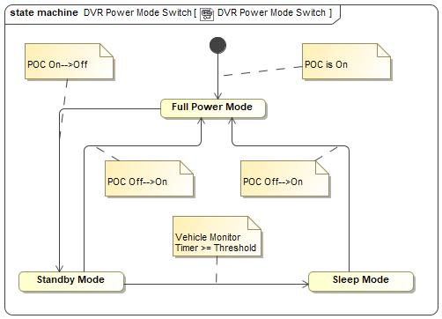

## XXXXX-REQ-xxxxxx/A-Preconditions of Recording

The DVR feature shall only start recording when the video record is enabled and memory device is available, if memory device is not available, error message should be sent from DVRServer to DVROnboardClient/DVROffboardClient.

## XXXXX-REQ- xxxxxx /A-AR Camera Integration

The camera in DVRServer will also serve for AR feature in DVROnboardClient, the format of the video captured by this camera should meet the requirement of DVR together with AR feature, video should be sent form DVRServer to DVROnboardClient via a LVDS cable.

## XXXXX-REQ- xxxxxx /A-Legal Regulation

The DVR system should design & implement according to < GB/T 38892-2020 >, the validation and feature sign-off should follow this GB/T.

## XXXXX-REQ- xxxxxx /A-DVR System Communication

DVRServer should support two-way communication with DVROnboardClient via IIC or UART over FPD-Link protocol.

DVRServer should support two-way communication with DVROffboardClient via Wi-Fi protocol.

## XXXXX-REQ- xxxxxx /A-Data Collection

DVROnboardClient is response to collect vehicle data and send them to DVRServer, there are two kinds of data:

1. Mandatory data:
   1. VIN number
   2. System date and time
2. Optional data:
   1. Airbag status
   2. Vehicle speed
   3. ABS status
   4. Brake status
   5. Double flashing lights and other lighting status
   6. Seat belt status

All above data will be used to support DVR functions.

# Functional Definition

## XXXXX-FUN-REQ-xxxxxx/A-Enable/Disable Video Record

### Requirements

Video Record function should keep enabled before user disables video record option on the DVR setting menu.

#### XXXXX-REQ-xxxxxx/A-First Time Usage

A notification should be shown on DVROnboardClient when the first time ignition on the vehicle, the description should contain DVR functions introduction and legal related clarification, need DVR user to confirm the information.

#### XXXXX-REQ-xxxxxx/A-Enable/Disable Switch

If video record is disabled

Video record should be enabled by default for every ignition cycle, DVRServer shall NOT save the enable/disable setting in memory, DVR could be switched between Enabled and Disabled via the DVR setting menu on DVROnboardClient or DVROffboardClient.

DVRServer should follow the principle of first come first served to manage the video record status, for example, if user enables video record through DVROnboardClient, DVROffboardClient also should show as enabled status, then if user disable video record via DVROffboardClient, DVRServer should synchronize this status to DVROnboardClient as disabled.

The DVROnboardClient shall provide a Recording Status Icon to inform video record status:

* Disabled—Grey
* Enabled—Green
* Recording—Red

The status of video record should not impact video capture for AR Navigation feature, for example, Video record is disabled and AR feature is enabled on DVROnboardClient, DVRServer will still capture the video and send it to DVROnboardClient, and the video will not be saved into eMMC or TF card of DVRServer.

### Use Cases

#### XXXXX-UC-REQ-xxxxxx/A-User enable/disable video record via DVROnboardClient successfully

|  |  |
| --- | --- |
| **Actors** | User, DVRServer, DVROnboardClient |
| **Pre-conditions** | DVRServer is at full power mode.  DVROnboardClient is at HMI on status  DVRServer memory device is available  Vehicle speed is less than threshold speed |
| **Scenario Description** | User enters DVR setting menu on DVROnboardClient  User selects to enable/disable video record |
| **Post-conditions** | Video record switches to enabled/disabled successfully  If enable:   * Video record should be available * The Recording Status Icon on DVROnboardClient HMI main page should be Green   if disable:   * Video record should be disabled * The Recording Status Icon on DVROnboardClient HMI main page should be Grey   DVR Server should synchronize the status to DVROffboardClient |
| **List of Exception Use Cases** | User enable/disable video record via DVROnboardClient failed. |
| **Interfaces** | UART, Wi-Fi, HMI |

#### XXXXX-UC-REQ-xxxxxx/A-User enable/disable video record via DVROnboardClient failed

|  |  |
| --- | --- |
| **Actors** | User, DVRServer, DVROnboardClient |
| **Pre-conditions** | DVRServer is at full power mode.  DVROnboardClient is at HMI on status  DVRServer memory device is available  Vehicle speed is less than threshold speed |
| **Scenario Description** | User enters DVR menu on DVROnboardClient  User selects to enable/disable video record |
| **Post-conditions** | Failed to control video record:   * An error message is displayed to the user * The Recording Status Icon on DVROnboardClient HMI main page should keep no change |
| **List of Exception Use Cases** |  |
| **Interfaces** | UART, HMI |

#### XXXXX-UC-REQ-xxxxxx/A-User enable/disable video record via DVROffboardClient successfully

|  |  |
| --- | --- |
| **Actors** | User, DVRServer, DVROffboardClient |
| **Pre-conditions** | DVRServer is at full power mode.  DVROffboardClient is actived  DVRServer memory device is available  Vehicle speed is less than threshold speed |
| **Scenario Description** | User enters DVR menu on DVROffboardClient  User selects to enable/disable video record |
| **Post-conditions** | DVR switches to enabled/disabled successfully  DVR Server should synchronize the status to DVROnboardClient |
| **List of Exception Use Cases** | User enable/disable video record via DVROffboardClient failed. |
| **Interfaces** | UART, Wi-Fi, HMI |

#### XXXXX-UC-REQ-xxxxxx/A-User enable/disable video record via DVROffboardClient failed

|  |  |
| --- | --- |
| **Actors** | User, DVRServer, DVROffboardClient |
| **Pre-conditions** | DVRServer is at full power mode.  DVROffboardClient is actived  DVRServer memory device is available  Vehicle speed is less than threshold speed |
| **Scenario Description** | User enters DVR menu on DVROffboardClient  User selects to enable/disable video record |
| **Post-conditions** | Video record is unable switch:   * An error message is displayed to user |
| **List of Exception Use Cases** |  |
| **Interfaces** | Wi-Fi, HMI |

### White Box View

#### Activity Diagrams

##### XXXXX-ACT-REQ-xxxxxx/A-User enable/disable video record via DVROnboardClient

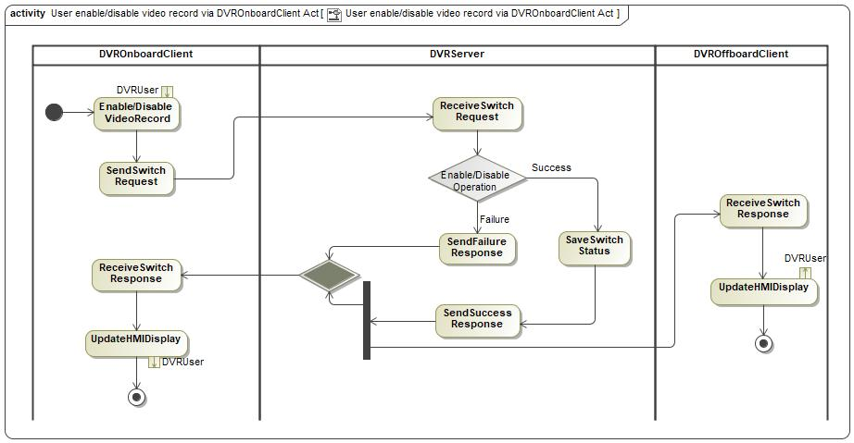

##### XXXXX-ACT-REQ-xxxxxx/A-User enable/disable video record via DVROffboardClient

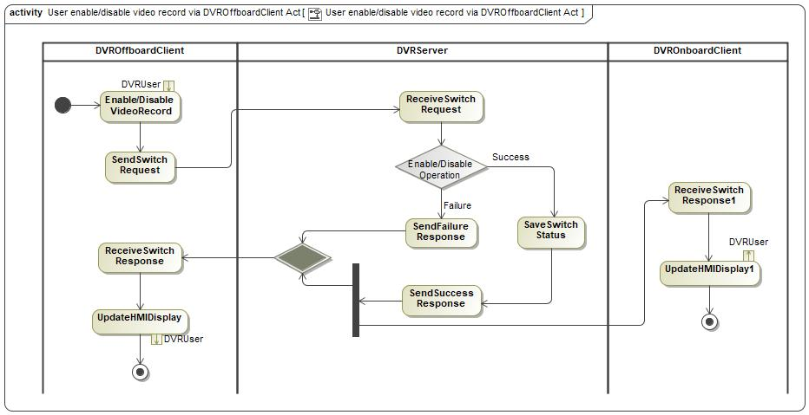

#### Sequence Diagrams

##### XXXXX-SD-REQ-xxxxxx/A-User enable/disable video record via DVROnboardClient

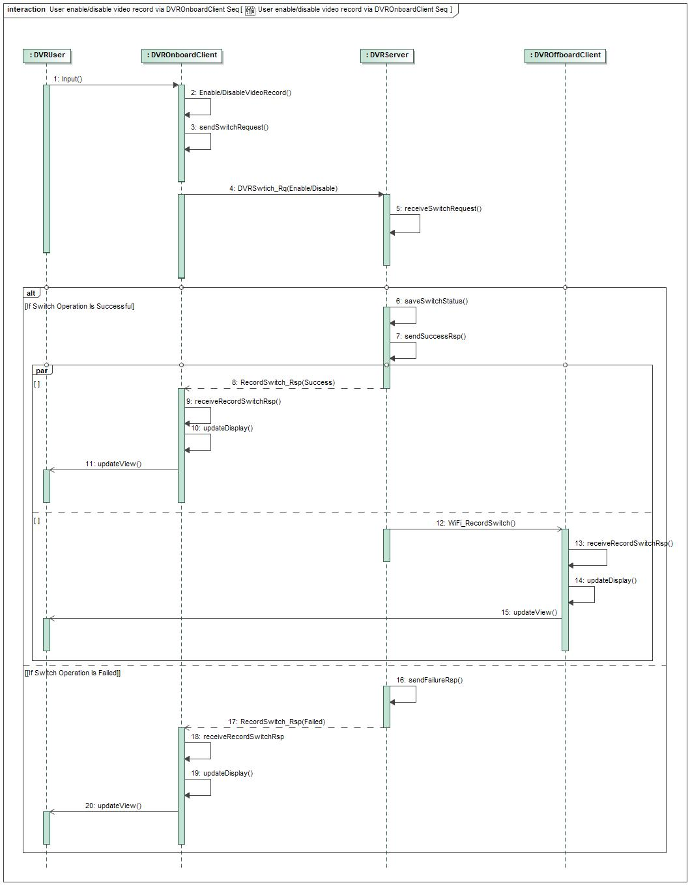

##### XXXXX-SD-REQ-xxxxxx/A-User enable/disable video record via DVROffboardClient

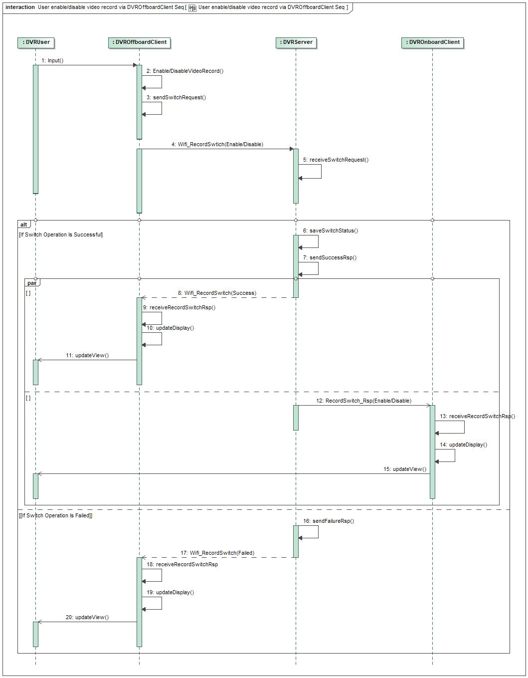

## XXXXX-FUN-REQ-xxxxxx/A-Video/Photo~~/Voice~~ Data Record and Save

### Requirements

DVRServer should have ability to save video/photo~~/voice~~ for user to playback or copy.

#### XXXXX-REQ-xxxxx/A-File Saving

There are four kinds of data could be recorded into DVRServer eMMC.

|  |  |  |  |  |
| --- | --- | --- | --- | --- |
| File Type | Resolution | Format | Save Location | Allocation Size |
| Normal Video | 1080P | MP4 | “Normal Data” folder in eMMC | 80% of eMMC storage size |
| Emergency Video | 1080P | MP4 | “Key Data” folder in eMMC | 20% of eMMC storage size |
| Manual Video | 1080P | MP4 |
| Manual Photo | 1920*1080 | JPG |

DVRServer should follow FIFO design to make sure the newest data could cover the oldest one when memory is full, all videos should be encoded by H.264 and save as MP4 format, and photos should be saved in JPG format. File storage system in eMMC should include:

1. “Normal Data” folder
2. “Key Data” folder

File system in TF card should only include one “Key Data” folder, DVRServer should support 8~128GB size TF card.

There are three ways to save files:

1. eMMC: All of the data must be saved into an DVRServer internal eMMC, the size of eMMC should support at least 4 hours video data storage according to GB/T 38892.
2. TF Card: If User inserts TF card into DVRServer, Emergency video will be saved into TF card “Key Data” folder automatically and other files could be saved into TF card manually via DVROnboardClient and DVROffboardClient HMI.
3. Smart Phone: User could copy files to smart phone local file system via Wi-Fi connection between DVROffboardClient & DVRServer.

#### XXXXX-REQ-xxxxx/A-Data Deletion and naming

Data in EMMC could not be deleted according to GB/T 38892, data in TF card could be deleted by DVR user.

Data naming rules as below:

1. Normal Video: NOR-Year-Month-Day Hour-Minute-Second.mp4
2. Emergency Video: EVT-Year-Month-Day Hour-Minute-Second.mp4
3. Manual Video: MAN-Year-Month-Day Hour-Minute-Second.mp4
4. Manual Photo: PHO-Year-Month-Day Hour-Minute-Second.jpg

All video/photo files should be named as: <Year-Month-Day Hour-Minute-Second am/pm>. For example, “2022-04-22 03-43-52 pm.mp4” and “2022-05-09 10-11-05 am.jpg”.

#### XXXXX-REQ-xxxxxx/A- Vehicle Information Overlay

DVRServer should have the ability to overlay the necessary information on the video or photo recorded, there are two kinds of information could be overlay onto video or photo:

1. Mandatory information: these information must be displayed on video data.
   1. VIN number
   2. Video/Photo date and time
2. Optional information: DVR user could choose if these information will be displayed on video data or not.
   1. ~~Voice record status~~
   2. Wi-Fi connection status
   3. Cornering Lamp status
   4. Seatbelt status
   5. Vehicle speed
   6. Break status
   7. Airbag status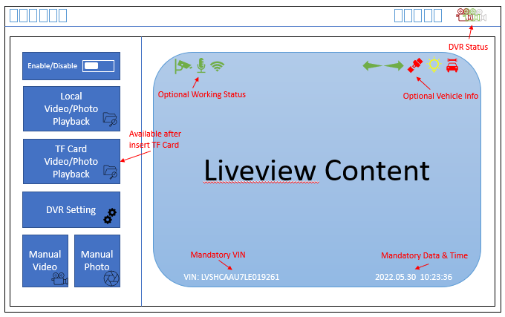

#### XXXXX-REQ-xxxxxx/A-Normal Video Record

Once DVR is enabled and memory device is available, DVRServer should start normal video recording automatically. The default normal video duration is 3 minutes and should be saved into “Normal Data” folder.

#### XXXXX-REQ-xxxxxx/A-Emergency Video Record

DVRServer should has the ability to detect the vehicle collision via internal G-Sensor and vehicle input data like vehicle speed, then trigger emergency video recording, and should be saved into “Key Data” folder. Emergency video should contain 15 seconds before collision happens and 30 seconds after collision detection, and should be saved into “Key Data” folder.

#### XXXXX-REQ-xxxxxx/A-Manual Video/Photo Record

There are four ways to trigger manual video record:

1. Soft button on DVROnboardClient HMI
2. Voice control via DVROnboardClient if available
3. Gesture control via DVROnboardClient if available
4. Soft button on DVROffboardClient HMI

Once manual video record is actived, the Recording Status Icon should be Red, and DVRServer shall save a video that contain 15 seconds before manual triggered and 30 seconds after manual triggered(或者可控的变长视频？只定义视频时长的上限？). Manual video should be saved into “Key Data” folder.

There are two ways to trigger manual photo record:

1. Soft button on DVROnboardClient menu, will take a photo of live view.
2. Soft button on DVROffboardClient menu, will take a photo of live view.
3. Screenshot button on video play back screen

Manual photo should be saved into “Key Data” folder.

#### ~~XXXXX-REQ-xxxxxx/A-Voice Record~~

~~All video record by DVR system, should also include the in-vehicle sound data, the voice and video should keep sync in EMMC or TF card or smart phone.~~

~~No request to transform voice data to DVROnboardClient, which means user could replay the video on DVROnboardClient without sound.~~

### Use Cases

#### XXXXX-UC-REQ-xxxxxx/A-Normal Video Record

|  |  |
| --- | --- |
| **Actors** | DVRServer |
| **Pre-conditions** | Video record is enabled  DVRServer is in full power mode  DVRServer memory device is available, and no error detected |
| **Scenario Description** | DVRServer continues to do video recording periodically |
| **Post-conditions** | Video should be saved into eMMC normal data folder with same naming rule |
| **List of Exception Use Cases** | Failed to Video/Photo Record |
| **Interfaces** |  |

#### XXXXX-UC-REQ- xxxxxx/A-Emergency Video Record

|  |  |
| --- | --- |
| **Actors** | DVRServer, DVROnboardClient |
| **Pre-conditions** | Video record is enabled  DVRServer is in full power mode  DVRServer memory device is available, and no error detected  Vehicle collision event is detected by DVRServer |
| **Scenario Description** | DVRServer should trigger an emergency video recording, the video should contains 30 seconds before emergency detection and 30 seconds after emergency detection |
| **Post-conditions** | The emergency video should be saved into key data folder with same naming rule  Notify user that a new emergency Video is captured through DVROnboardClient HMI. |
| **List of Exception Use Cases** | Failed to Video/Photo Record |
| **Interfaces** | UART, HMI |

#### XXXXX-UC-REQ- xxxxxx/A-Manual Video/Photo Record

|  |  |
| --- | --- |
| **Actors** | User, DVRServer, DVROnboardClient, DVROffboardClient |
| **Pre-conditions** | Video record is enabled  DVRServer is in full power mode  DVRServer memory device is available, and no error detected  Soft button or voice control or gesture control is triggered by user on DVROnboardClient or soft button is triggered by user on DVROffboardClient |
| **Scenario Description** | DVRServer should trigger a manual video recording |
| **Post-conditions** | The manual video/photo should be saved into key data folder with same naming rule  Notify user that a new manual video/photo is saved successfully |
| **List of Exception Use Cases** | Failed to Video/Photo Record |
| **Interfaces** | UART, Wi-Fi, HMI |

#### XXXXX-UC-REQ- xxxxxx/A-Failed to Video/Photo Record

|  |  |
| --- | --- |
| **Actors** | User, DVRServer, DVROnboardClient, DVROffboardClient |
| **Pre-conditions** | Video record is enabled  DVRServer is in full power mode  When normal or emergency or manual video/photo record is triggered |
| **Scenario Description** | DVRServer detects there is an internal issue, includes memory(eMMC) broken, camera HW failure, etc. |
| **Post-conditions** | An error message should be displayed to user via DVROnboardClient HMI.  An error message should be displayed to user via DVROffboardClient HMI if Wi-Fi connection enabled.  Related error info should be saved and DTCs should be triggered |
| **List of Exception Use Cases** |  |
| **Interfaces** | UART, Wi-Fi, HMI |

### White Box View

#### Activity Diagrams

##### XXXXX-ACT-REQ- xxxxxx/A-Normal Video Record

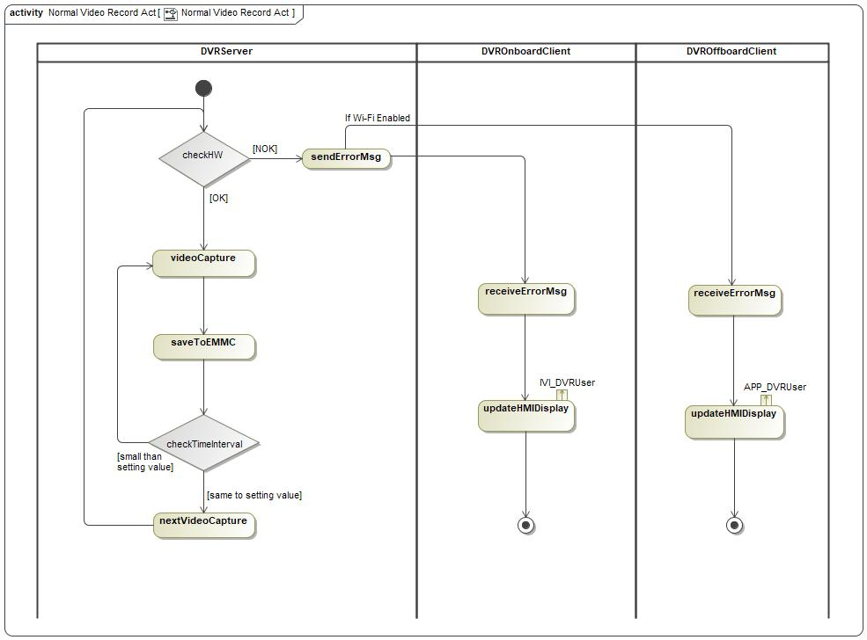

##### XXXXX-ACT-REQ- xxxxxx/A-Emergency Video Record

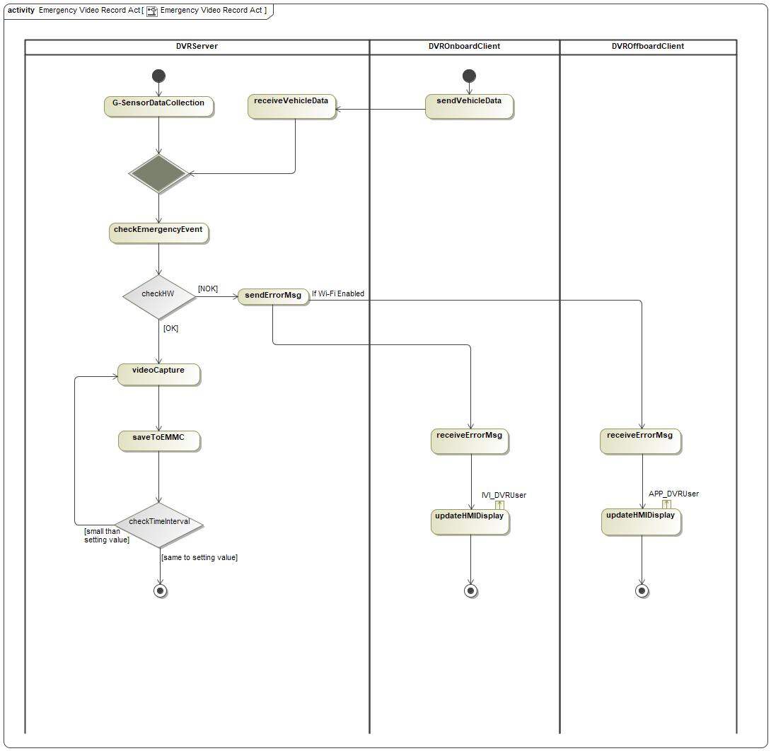

##### XXXXX-ACT-REQ- xxxxxx/A-Manual Video or Photo Record

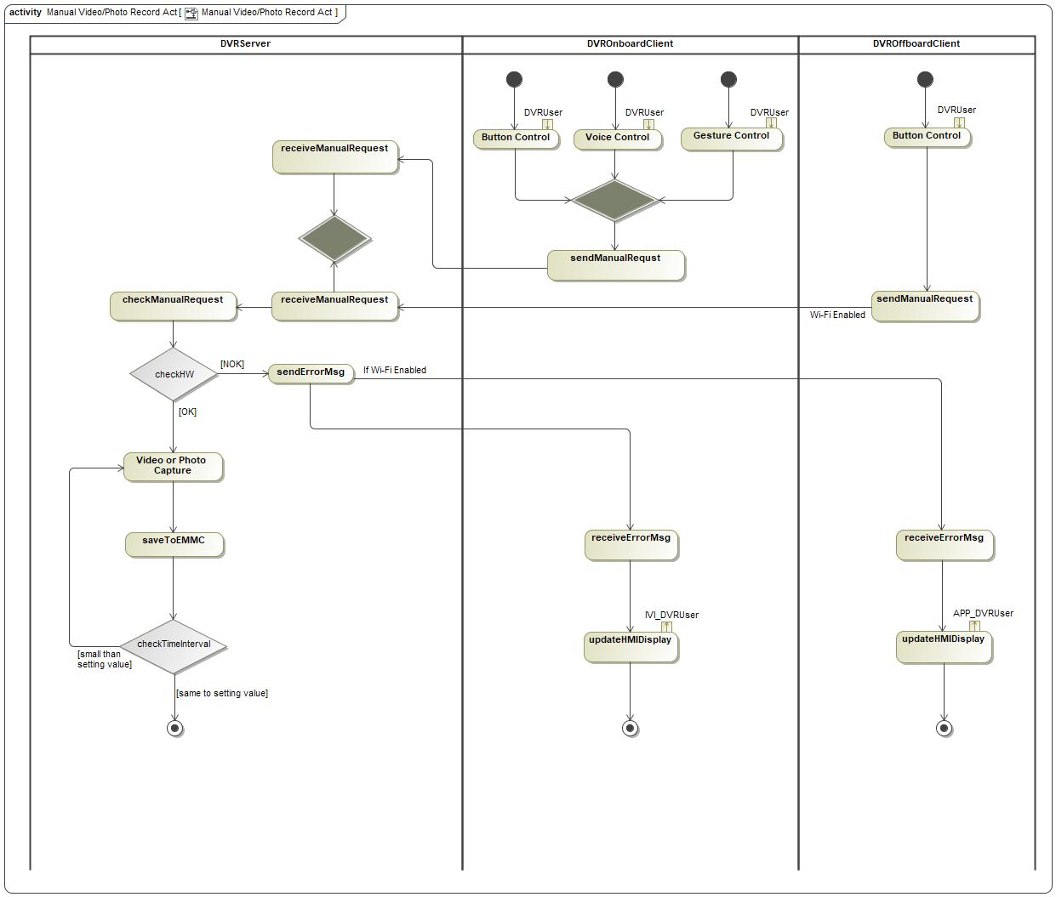

#### Sequence Diagrams

##### XXXXX-SD-REQ- xxxxxx/A-Normal Video Record

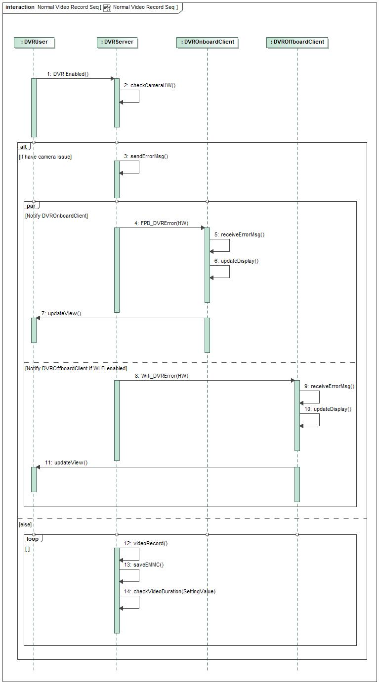

##### XXXXX-SD-REQ- xxxxxx/A-Emergency Video Record

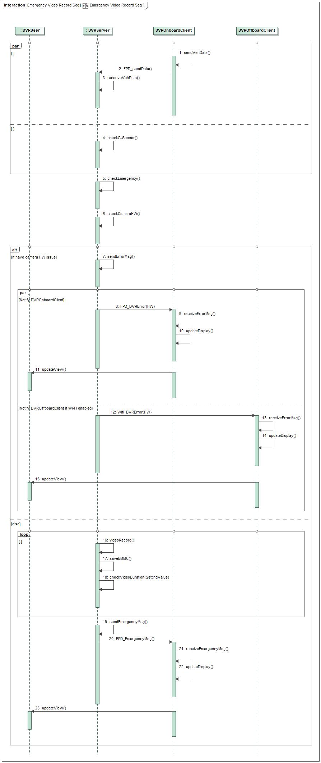

##### XXXXX-SD-REQ- xxxxxx/A-Manual Video Record

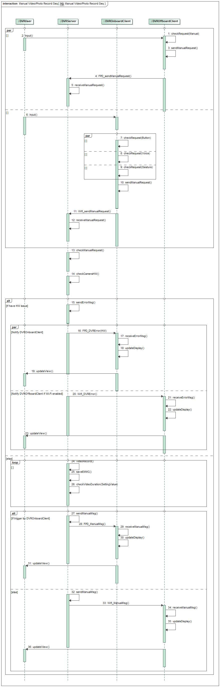

## XXXXX-FUN-REQ-xxxxxx/A-Video/Photo Display

### Requirements

DVROnboardClient and DVROffboardClient should have ability to provide video view HMI for user.

#### XXXXX-REQ-xxxxxx/A-Video Liveview

DVR system shall support video liveview for user to preview the video, liveview should be actived once DVR is enabled and user enters DVR menu main page on DVROnboardClient or DVROffboardClient.

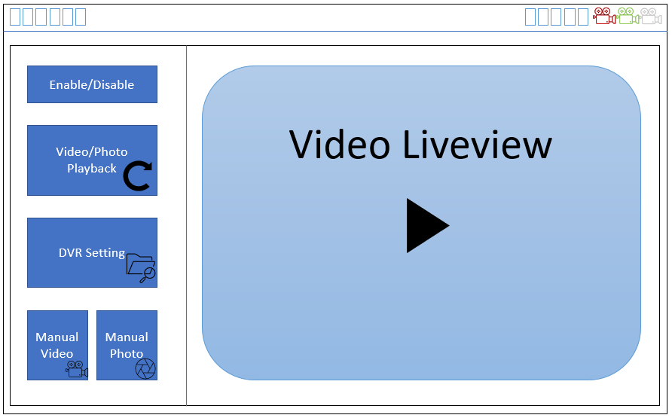

DVROnboardClient DVR Main Page

The delay between video is captured and displayed should less than 0.5s, this requirement both apply for LVDS connection to DVROnboardClient and Wi-Fi connection to DVROffboardClient.

#### XXXXX-REQ-xxxxxx/A-Video/Photo Playback List

DVR system shall support video/photo playback for user to easy replay the video/photo. When user enter Video/Photo playback sub-menu on DVROnboardClient or DVROffboardClient, video list should be shown for user to select, after one of the video is chosen, corresponding video should be played immediately:

1. The newest Video should be highlight in the playback list.
2. All files should be sorted by date.
3. The totally video/photo number of one date should be displayed.

below is the HMI example on DVROnboardClient:

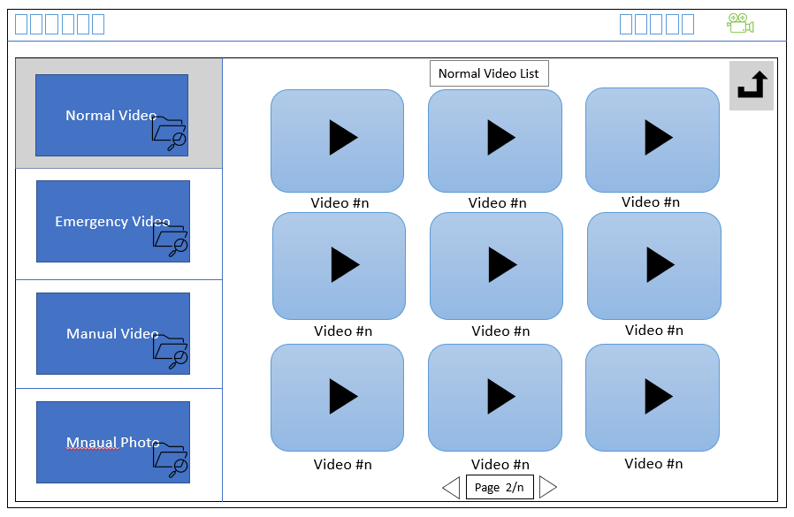

DVROnboardClient Video Playback List

Playback function only available when DVR is enabled and vehicle speed is less than threshold speed (for example 5 km/h), DVRServer should read the data in EMMC or TF card and send it to DVROnboardClient or DVROffboardClient for replay, When video playback is actived, AR video capture and Section 4.2 video record function will be disabled.

#### XXXXX-REQ-xxxxxx/A-Video/Photo Playback Control

User could do start/stop/forward/backward operation via DVROnboardClient or DVROffboardClient.

A progress bar is preferred to support video forward and backward easily.

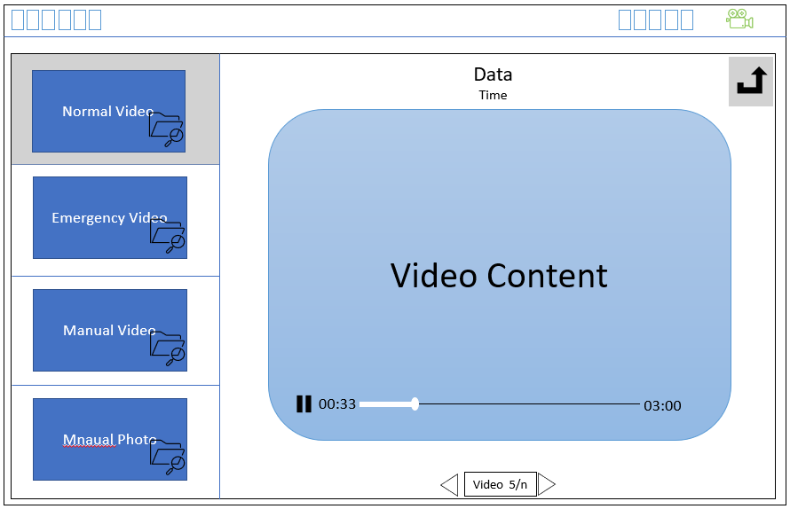

DVROnboardClient DVR Playback Page

### Use Cases

#### XXXXX-UC-REQ-xxxxxx/A-Video Liveview on DVROnboardClient or DVROffboardClient

|  |  |
| --- | --- |
| **Actors** | User, DVRServer, DVROnboardClient, DVROffboardClient |
| **Pre-conditions** | Normal video record function is running |
| **Scenario Description** | User enters DVR main page menu on DVROnboardClient or DVROffboardClient |
| **Post-conditions** | Normal video will be displayed on DVROnboardClient or DVROffboardClient DVR main page menu |
| **List of Exception Use Cases** |  |
| **Interfaces** | HMI, LVDS, Wi-Fi |

#### XXXXX-UC-REQ-422181/A-Video/Photo Playback on DVROnboardClient or DVROffboardClient

|  |  |
| --- | --- |
| **Actors** | User, DVRServer, DVROnboardClient, DVROffboardClient |
| **Pre-conditions** | DVR system is enabled  No memory issue is detected by DVRServer  vehicle speed is less than threshold value |
| **Scenario Description** | User enters one of the DVR video/photo playback folder:   * “Normal Data” folder * “Key Data” folder   And one of the video or photo is chosen. |
| **Post-conditions** | Video or photo is displayed on DVROnboardClient or DVROffboardClient |
| **List of Exception Use Cases** |  |
| **Interfaces** | HMI, LVDS, Wi-Fi |

#### XXXXX-UC-REQ-422182/A-Video Playback Control

|  |  |
| --- | --- |
| **Actors** | User, DVRServer, DVROnboardClient, DVROffboardClient |
| **Pre-conditions** | Video playback is happening on DVROnboardClient or DVROffboardClient |
| **Scenario Description** | User selects the start/stop/forward/backward soft button on DVROnboardClient or DVROffboardClient |
| **Post-conditions** | One of the operations need to be performed by DVRServer according to user selection: start/stop/forward/backward. |
| **List of Exception Use Cases** |  |
| **Interfaces** | HMI, LVDS, Wi-Fi |

#### XXXXX-UC-REQ-422182/A-Video Playback Timeout(是否必须存在？？)

|  |  |
| --- | --- |
| **Actors** | User, DVRServer, DVROnboardClient, DVROffboardClient |
| **Pre-conditions** | Video playback is happening on DVROnboardClient or DVROffboardClient, |
| **Scenario Description** | User selects to stop video playback on DVROnboardClient or DVROffboardClient, and keep this status more than a threshold value (1 mins for example) |
| **Post-conditions** | DVRServer informs DVROnboardClient or DVROffboardClient to go back to DVR video liveview main page. |
| **List of Exception Use Cases** |  |
| **Interfaces** | HMI, LVDS, Wi-Fi |

### White Box View

#### Activity Diagrams

##### XXXXX-ACT-REQ-xxxxxx/A-Video Liveview

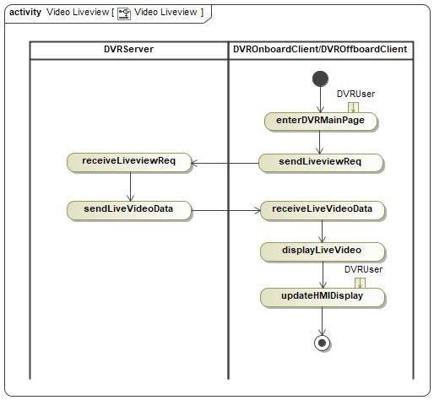

##### XXXXX-ACT-REQ-xxxxxx/A-Video Playback

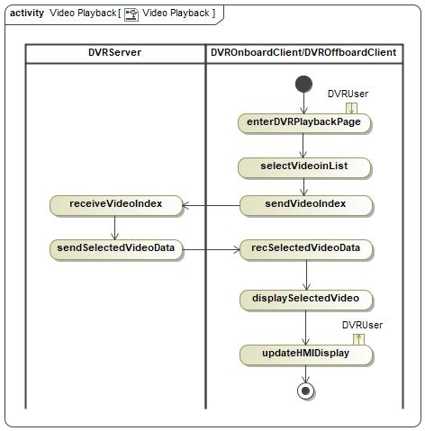

##### XXXXX-ACT-REQ-xxxxxx/A-Video Playback Start/Stop/Forward/Backward Control

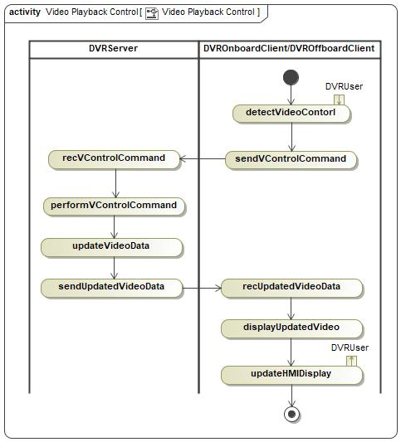

##### XXXXX-ACT-REQ-xxxxxx/A-Video Playback Stop Timeout

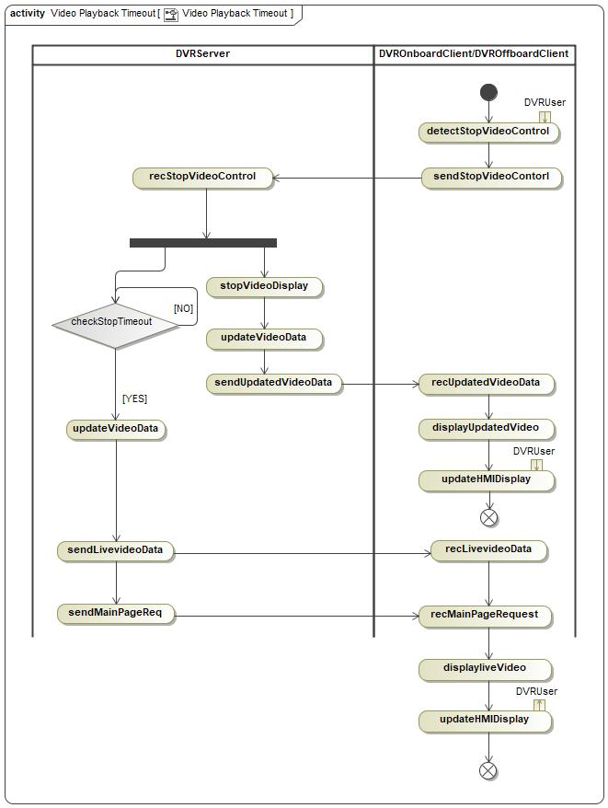

#### Sequence Diagrams

##### XXXXX-SD-REQ-xxxxxx/A-PLACEHOLDER

##### XXXXX-SD-REQ-xxxxxx/A-PLACEHOLDER

##### XXXXX-SD-REQ-xxxxxx/A-PLACEHOLDER

## XXXXX-FUN-REQ-xxxxxx/A-DVR Setting & Information Display

### Requirements

All DVR setting and necessary information should be provided to user via DVROnboardClient or DVROffboardClient HMI.

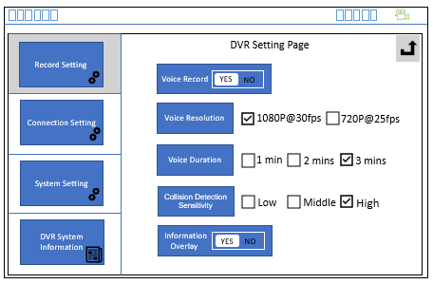

#### XXXXX-REQ-xxxxxx/A-DVR Setting Content

The DVROnboardClient and DVROffboardClient should provide below setting option to DVR user:

|  |  |  |  |  |  |
| --- | --- | --- | --- | --- | --- |
| ID | Classification | Setting Name | Optional Value | Default Value | Function Description |
| 1 | Record Setting | ~~Voice Record~~ | ~~Enable/Disable~~ | ~~Disable~~ | ~~Choose if video record together with voice record~~ |
| 2 | Video Resolution | 1080P / 720P | 1080P | Choose the resolution of video record |
| 3 | Video Duration | 1 / 2 / 3 minutes | 3 minutes | Choose the length of the normal and manual video |
| 4 | Collision Detection Sensitivity | High / Middle / Low | Middle | Choose the sensitivity of the G-Sensor in DVRServer |
| 5 | Vehicle Information Overlay | Enable/Disable | Enable | Choose if optional information(section 4.2.1.2) will be overlay onto Video/Photo |
| 6 | Connection Setting | DVR Wi-Fi Hotspot Setting | SSID & Password | SSID:Ford DVR WHS  Password: 123456 | For user to modify the SSID and password of the DVR Wi-Fi connection |
| 7 | System Setting | Restore to Factory Defaults Setting | Yes/No | No | Allow user to rollback all the setting value to factory defaults |
| 8 | Format TF Card | Yes/No | No | Erase all TF data |
| ~~9~~ | ~~Language Option~~ | ~~Chinese / English~~ | ~~Chinese~~ | ~~Choose language of the setting system~~ |

#### XXXXX-REQ-xxxxxx/A-DVR Information Display

The DVROnboardClient should display below information to DVR user:

|  |  |  |  |  |
| --- | --- | --- | --- | --- |
| ID | Classification | Information Name | Value Example | Description |
| 1 | DVR Information | DVR Firmware Version | 3.6.9.4v | DVRServer SW version |
| 2 | DVR Memory Status | 70% | EMMC usage status |
| 3 | TF Card Memory Status | 16% | TF card usage status |

#### XXXXX-REQ- xxxxxx /A-Setting Change when Recording is Active

If recording is already active and a setting change (Resolution, Recording time, etc.) occurs through DVROnboardClient/ DVROffboardClient, DVROnboardClient/ DVROffboardClient shall send StopRecording_Rq to DVRServer to end the current recording, and send StartRecording_Rq to DVRServer to start a new recording once the new settings take effect.

#### XXXXX-REQ- xxxxxx /A-Settings Storage

The IDCMServer shall be capable to store settings option from DVROnboardClient and DVROffboardClient. Follow FIFO strategy, If Wi-Fi connection is setup, new setting data from DVROnboardClient will overwrite the old data from DVROffboardClient, and verse vice.

#### XXXXX-REQ- xxxxxx /A-Settings Value Synchronization

Whenever user enters DVROnboardClient / DVROffboardClient setting page, DVRServer should send the newest setting value to DVROnboardClient / DVROffboardClient for synchronization.

### Use Cases

#### XXXXX-UC-REQ-xxxxxx/A-Modify DVR Setting via DVROnboardClient or DVROffboardClient

|  |  |
| --- | --- |
| **Actors** | User, DVRServer, DVROnboardClient, DVROffboardClient |
| **Pre-conditions** | DVRServer is in full power mode |
| **Scenario Description** | User changes the setting value via DVROnboardClient or DVROffboardClient menu. |
| **Post-conditions** | DVRServer accepts the new setting value and send the same value back to DVROnboardClient and DVROffboardClient to update HMI display. |
| **List of Exception Use Cases** | Failed to Modify DVR setting or read DVR Information |
| **Interfaces** | HMI, UART, Wi-Fi |

#### XXXXX-UC-REQ-xxxxxx/A-DVR Information Update via DVROnboardClient or DVROffboardClient

|  |  |
| --- | --- |
| **Actors** | User, DVRServer, DVROnboardClient, DVROffboardClient |
| **Pre-conditions** | DVRServer is in full power mode |
| **Scenario Description** | User tries to read the DVR information via DVROnboardClient or DVROffboardClient menu |
| **Post-conditions** | DVRServer sends the request information to DVROnboardClient or DVROffboardClient to display |
| **List of Exception Use Cases** | Failed to Modify DVR setting or read DVR Information |
| **Interfaces** | HMI, UART, Wi-Fi |

#### XXXXX-UC-REQ-xxxxxx/A-Failed to Modify DVR setting or read DVR Information

|  |  |
| --- | --- |
| **Actors** | User, DVRServer, DVROnboardClient, DVROffboardClient |
| **Pre-conditions** | DVRServer is in full power mode |
| **Scenario Description** | User tries to modify DVR setting or ready DVR system information via DVROnboardClient or DVROffboardClient menu |
| **Post-conditions** | DVRServer could not feedback right setting value or information  DVROnboardClient or DVROffboardClient pops up error message to User “Failed to Set DVR” or “Failed to Read DVR Information” |
| **List of Exception Use Cases** |  |
| **Interfaces** | HMI, UART, Wi-Fi |

### White Box View

#### Activity Diagrams

##### XXXXX-ACT-REQ-xxxxxx/A- Modify DVR Setting via DVROnboardClient

Modify DVR Setting via DVROffboardClient should follow same strategy.

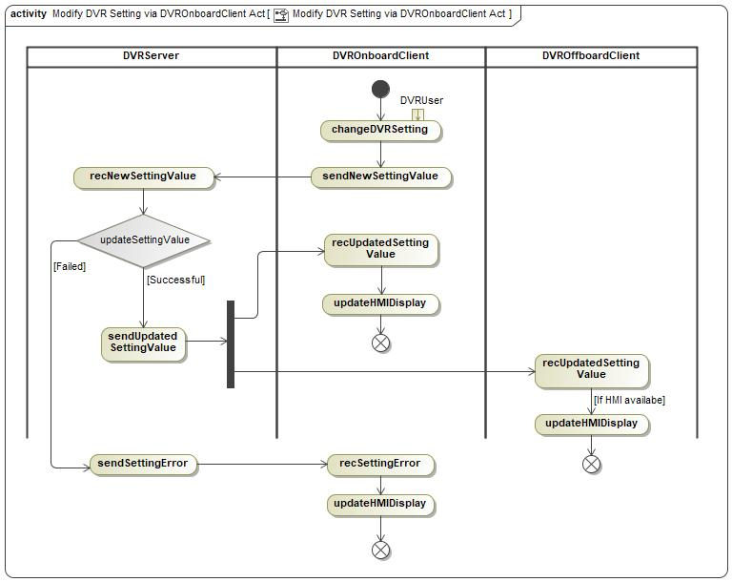

##### XXXXX-ACT-REQ-xxxxxx/A- DVR Information Update via DVROnboardClient

Read DVR information via DVROffboardClient should follow same strategy.

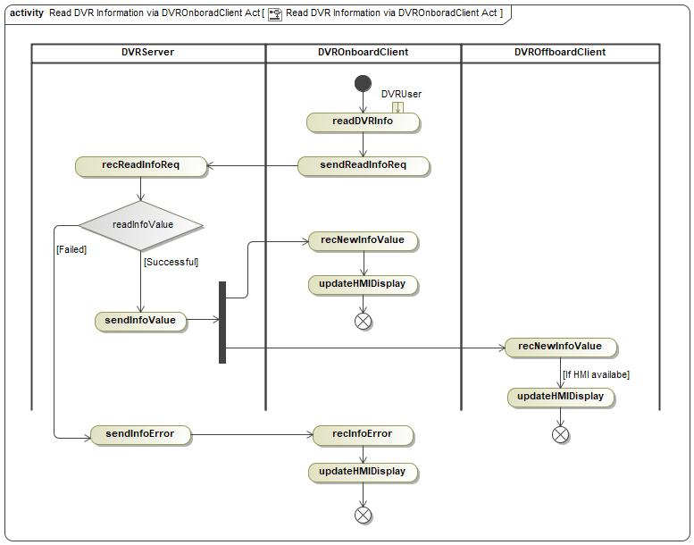

#### Sequence Diagrams

##### XXXXX-SD-REQ-xxxxxx/A-PLACEHOLDER

##### XXXXX-SD-REQ-xxxxxx/A-PLACEHOLDER

## XXXXX-FUN-REQ-xxxxxx/A-Data Copy and Deletion

### Requirements

All video/photo data should be saved into eMMC in DVRServer, DVR system support below methods for copy and deletion:

1. Copy data in eMMC to TF card manually via DVROnboardClient or DVROffboardClient.
2. Copy data in eMMC to smartphone manually via DVROffboardClient.
3. Data in eMMC could not be deleted according to GB/T 38892-2020 section 5.3.4.1.
4. Data in TF card could be deleted via DVROnboardClient or DVROffboardClient.

#### XXXXX-REQ-xxxxxx/A- Precondition of Data Copy and Deletion

TF card should be insert into DVRServer as the precondition for TF card copy and deletion.

Wi-Fi connection should be setup as the precondition for data copy and deletion via DVROffboardClient.

#### XXXXX-REQ-xxxxxx/A- Data Copy to TF Card via DVROnboardClient or DVROffboardClient

In normal / emergency / manual video playback menu or manual photo playback menu, user could choose one or more data to be copied into TF card.

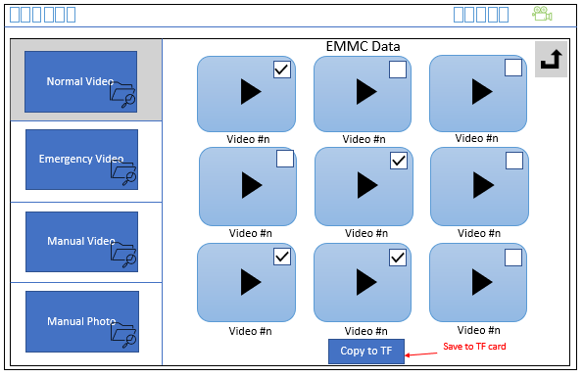

#### XXXXX-REQ-xxxxxx/A- One-Click Copy Video to TF Card

For better user experience, when a special event occurs, if DVR user wants to save the latest video to the TF card as soon as possible, user could click the button on DVR main page to quickly copy the latest three normal videos from eMMC to TF card (manual video folder).

#### XXXXX-REQ-xxxxxx/A- Data Copy to Smartphone

In DVROffboardClient normal / emergency / manual video playback menu or manual photo playback menu, user could choose one or more data to be copied to smartphone local memory.

#### XXXXX-REQ-xxxxxx/A- Memory Full Notification

If TF card or smartphone local memory is near to full, DVR should popup warning message to customer.

#### XXXXX-REQ-xxxxxx/A- Data Deletion in TF card

In TF card normal normal / emergency / manual video playback menu or manual photo playback menu, user could choose one or more data to be deleted via DVROnboardClient or DVROffboardClient.

### Use Cases

#### XXXXX-UC-REQ-xxxxxx/A- Data Copy to TF Card via DVROnboardClient or DVROffboardClient

|  |  |
| --- | --- |
| **Actors** | User, DVRServer, DVROnboardClient, DVROffboardClient |
| **Pre-conditions** | DVRServer is in full power mode |
| **Scenario Description** | User selects one or more videos/photos in playback menu, and click “Copy to TF card” button |
| **Post-conditions** | Selected videos or photos is copied form DVRServer eMMC to TF card corresponding folder, for example, manual video in eMMC should be copied to manual folder in TF card  A “successfully copy” message should be display on DVROnboardClient or DVROffboardClient HMI |
| **List of Exception Use Cases** | Failed to Data copy and deletion |
| **Interfaces** | HMI, UART, Wi-Fi |

#### XXXXX-UC-REQ-xxxxxx/A- One-Click Copy Video to TF Card

|  |  |
| --- | --- |
| **Actors** | User, DVRServer, DVROnboardClient, DVROffboardClient |
| **Pre-conditions** | DVRServer is in full power mode |
| **Scenario Description** | User chooses “One-Click Copy” button on DVR main page |
| **Post-conditions** | The latest three normal video in DVRServer eMMC is copied into TF card manual video folder  A “successfully copy” message should be display on DVROnboardClient or DVROffboardClient HMI |
| **List of Exception Use Cases** | Failed to Data copy and deletion |
| **Interfaces** | HMI, UART, Wi-Fi |

#### XXXXX-UC-REQ-xxxxxx/A- Data Copy to Smartphone

|  |  |
| --- | --- |
| **Actors** | User, DVRServer, DVROffboardClient |
| **Pre-conditions** | DVRServer is in full power mode  Wi-Fi connection is setup between DVRServer and DVROffboardClient |
| **Scenario Description** | User selects one or more videos/photos in playback menu, and click “Copy to Smart Phone” button |
| **Post-conditions** | Selected videos or photos is copied form DVRServer eMMC to smartphone local memory  A “successfully copy” message should be display on DVROffboardClient HMI |
| **List of Exception Use Cases** | Failed to Data copy and deletion |
| **Interfaces** | HMI, Wi-Fi |

#### XXXXX-UC-REQ-xxxxxx/A- TF Card Data Deletion via DVROnboardClient or DVROffboardClient

|  |  |
| --- | --- |
| **Actors** | User, DVRServer, DVROnboardClient, DVROffboardClient |
| **Pre-conditions** | DVRServer is in full power mode |
| **Scenario Description** | User selects one or more videos/photos in TF card folder, and click “Delete” button |
| **Post-conditions** | Selected videos or photos is deleted from TF card  A “successfully deletion” message should be display on DVROnboardClient or DVROffboardClient HMI |
| **List of Exception Use Cases** | Failed to Data copy and deletion |
| **Interfaces** | HMI, UART, Wi-Fi |

#### XXXXX-UC-REQ-xxxxxx/A- Failed to Data copy and deletion

|  |  |
| --- | --- |
| **Actors** | User, DVRServer, DVROnboardClient, DVROffboardClient |
| **Pre-conditions** | DVRServer is in full power mode  eMMC or TF card or Wi-Fi connection is not available |
| **Scenario Description** | User try to perform any data copy or deletion action |
| **Post-conditions** | Failed to do data copy or deletion operation  A “Operation Fail” message should be display on DVROnboardClient or DVROffboardClient HMI |
| **List of Exception Use Cases** |  |
| **Interfaces** | HMI, UART, Wi-Fi |

### White Box View

#### Activity Diagrams

##### XXXXX-ACT-REQ-xxxxxx/A- Data Copy to TF Card via DVROnboardClient or DVROffboardClient

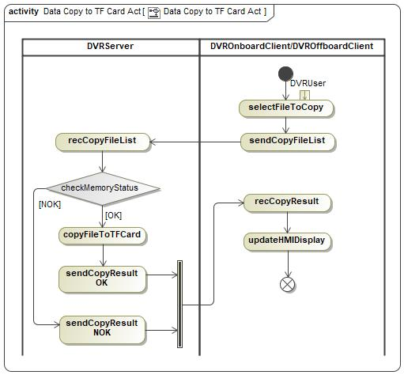

##### XXXXX-ACT-REQ-xxxxxx/A- Data Copy to Smartphone via DVROffboardClient

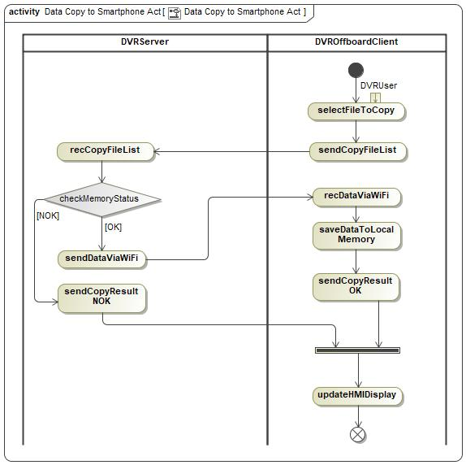

##### XXXXX-ACT-REQ-xxxxxx/A- Delete data in TF Card via DVROnboardClient or DVROffboardClient

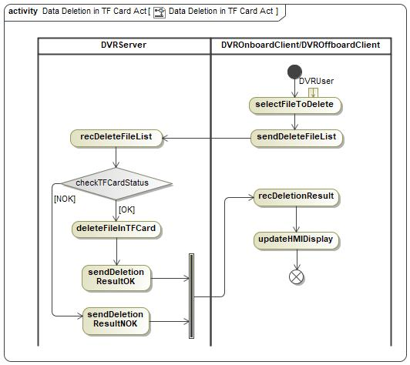

#### Sequence Diagrams

##### XXXXX-SD-REQ-xxxxxx/A-PLACEHOLDER

##### XXXXX-SD-REQ-xxxxxx/A-PLACEHOLDER

##### XXXXX-SD-REQ-xxxxxx/A-PLACEHOLDER

## XXXXX-FUN-REQ-xxxxxx/A-Vehicle Monitoring

### Requirements

DVR system shall provide vehicle monitor function after user left the vehicle, when DVR system is in standby power mode, DVRServer shall provide the ability to detect external collision and wakeup to do video recording, the monitor duration is controlled by Vehicle Monitor Timer.

#### XXXXX-REQ-xxxxxx/A-Collision Detection

The G-Sensor in DVRServer works as acceleration transducer, if acceleration test result is more than a threshold, vehicle monitor video record should be triggered, the threshold should be set via vehicle level calibration and configurable.

#### XXXXX-REQ-xxxxxx/A- Video Record When Vehicle Monitoring

The IDCMServer shall wake up and take a video record when vehicle monitor triggered, the video should contains 30 seconds after collision detected, and should be saved into DVRServer eMMC “Critical Video” folder.

#### XXXXX-REQ-422219/A- Wakeup Strategy

DVRServer shall only wake up itself in 2 seconds to do video record during whole vehicle monitoring status, should not send out any message to DVROnboardClient or DVROffboardClient.

#### XXXXX-REQ-xxxxxx/A- User Notification

When DVRServer goes into full power mode, if vehicle monitor video record happened in last standby mode, a warning message should be displayed on DVROnboardClient HMI to notify user that vehicle collision happened.

### Use Cases

#### XXXXX-UC-REQ-xxxxxx/A-Video Record When Vehicle Monitoring Successfully

|  |  |
| --- | --- |
| **Actors** | User, DVRServer, DVROnboardClient |
| **Pre-conditions** | Video record is enabled  DVRServer is in standby mode  DVRServer memory device is available, and no error detected  Vehicle collision is detected |
| **Scenario Description** | DVRServer wakes up and perform video record |
| **Post-conditions** | The new video is saved into eMMC “Critical Video” folder  DVRServer shall send message to DVROnboardClient to highlight this event when goes to full power mode next time. |
| **List of Exception Use Cases** | Failed to Video Record When Vehicle Monitoring |
| **Interfaces** | HMI, UART |

#### XXXXX-UC-REQ-xxxxxx/A- Failed to Video Record When Vehicle Monitoring

|  |  |
| --- | --- |
| **Actors** | User, DVRServer, DVROnboardClient |
| **Pre-conditions** | Video record is enabled  DVRServer is in standby mode  Vehicle collision is detected |
| **Scenario Description** | DVRServer wakes up but failed to perform video record |
| **Post-conditions** | DVRServer shall send message to DVROnboardClient to highlight this event when goes to full power mode next time. |
| **List of Exception Use Cases** |  |
| **Interfaces** | HMI, UART |

### White Box View

#### Activity Diagrams

##### XXXXX-ACT-REQ-xxxxxx/A- Video Record When Vehicle Monitoring

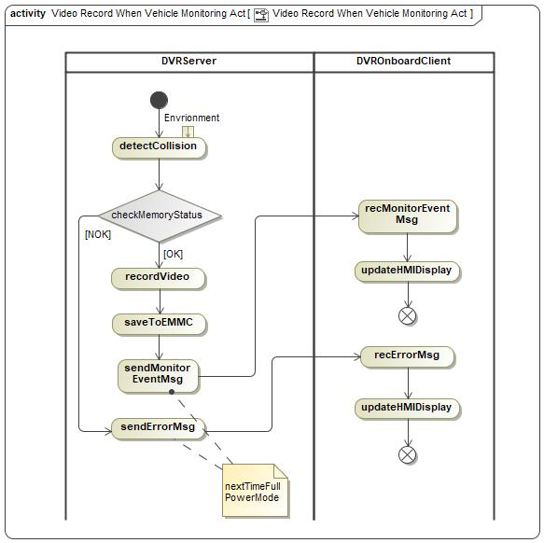

#### Sequence Diagrams

##### XXXXX-SD-REQ-xxxxxx/A-PLACEHOLDER

# Appendix: Reference Documents

|  |  |
| --- | --- |
| Reference # | Document Title |
| 1 | DVR IDCM and IVI interface SPSS |
| 2 |  |
| 3 |  |
| 4 |  |
| 5 |  |
| 6 |  |
| 7 |  |
| 8 |  |